|  |
| --- |
| **Lockedme.com**  **(Application Screenshots)** |

**Version History**

|  |  |
| --- | --- |
| Author | Harika Kadiyala |
| Purpose | Screenshots of the application |
| Date | August 10,2021 |
| Version | 1.0 |

Contents

1. Main menu screenshot 3

2. Displaying all files Screenshot 4

3. Adding a new file Screenshot 5

4. Deleting a file Screenshot 6

5. Searching a file Screenshot 7

6. Exit from the main menu 8

# Main menu screenshot

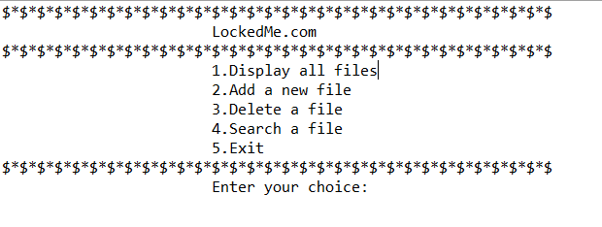

# Displaying all files Screenshot

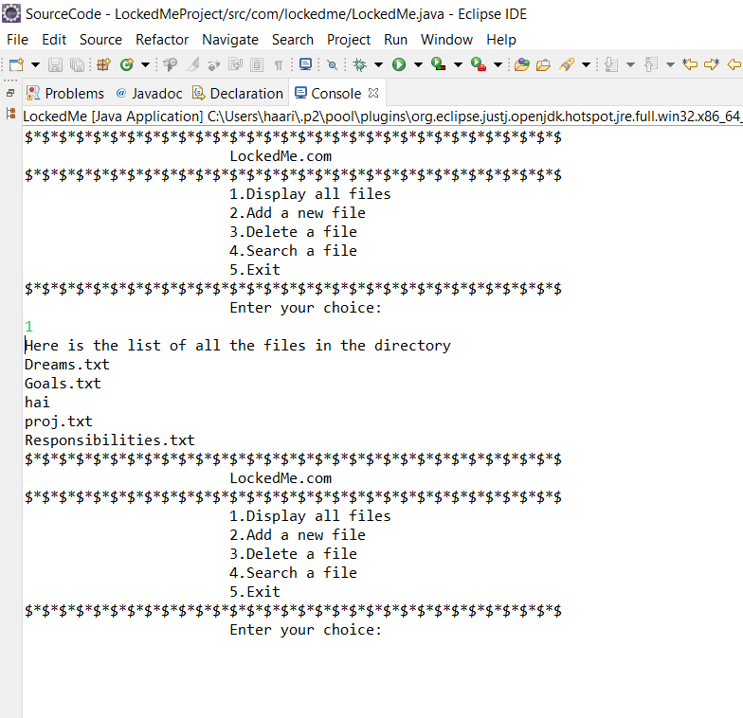

# Adding a new file Screenshot

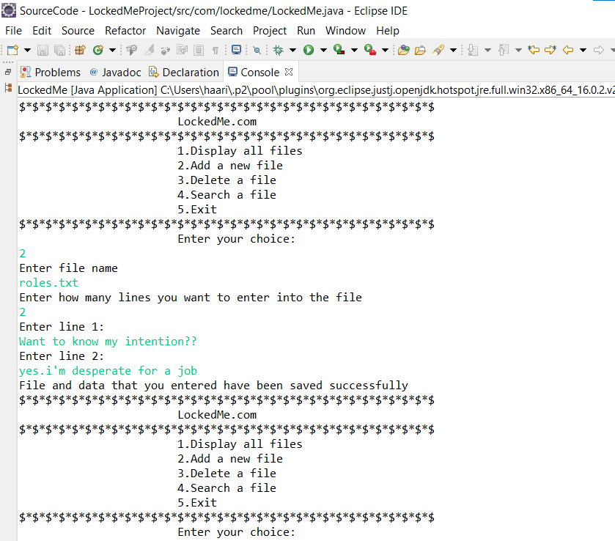

# Deleting a file Screenshot

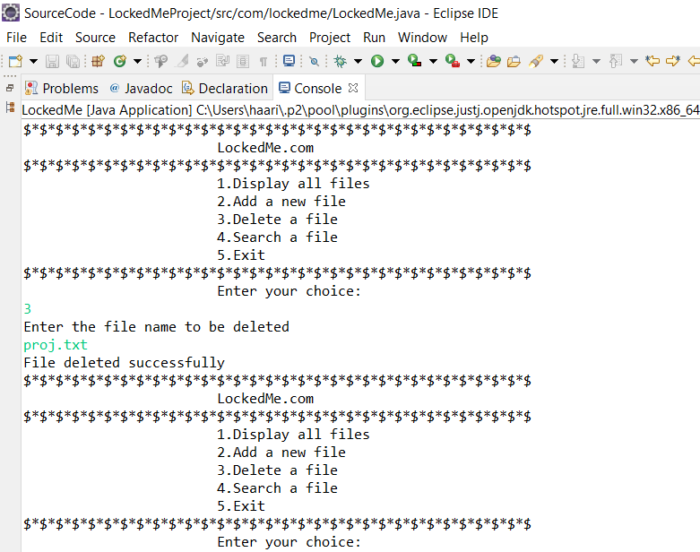

# Searching a file Screenshot

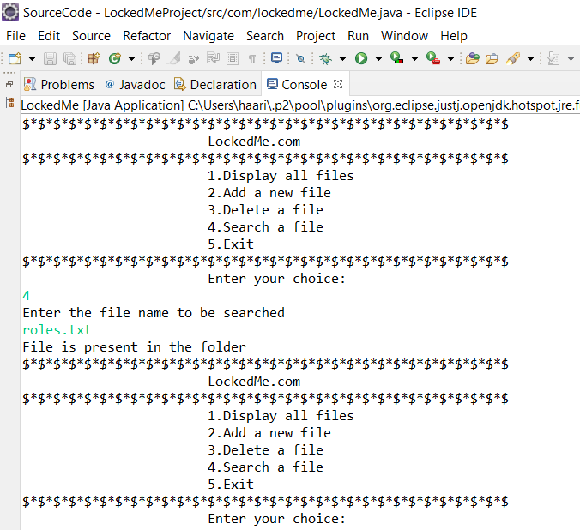

# Exit from the main menu

